BIGROCKS OPERATIONS PERFORMANCE AUTOMATION REPORT
This Big Rocks automation is the flagship project in the portfolio, combining Python, Airflow and deep contact-centre domain knowledge to deliver a daily KPI pack that senior leadership actually runs the business on.
Business purpose and audience
The solution produces a consolidated Big Rocks KPI workbook for the Customer Operations Director, Customer Marketing Director and all operations department heads (Back Office, Customer Care, Customer Service, DIY, Field/Guard teams).
Its goal is to answer one question every day: Are we delivering the level of service and protection promised to customers, across every channel and team?

Architecture and data flow
Operational databases are refreshed via Apache Airflow, which schedules the extraction and loading of call logs, WhatsApp/chat data, maintenance systems and case-management tables into analytics-ready schemas.
After the data is refreshed, a modular Python KPI engine (calls_data.py, cust_care.py, cust_service.py, back_office.py, diy.py, orchestrated by main.py) is run to calculate metrics and write them into a structured Big-Rocks.xlsx report.
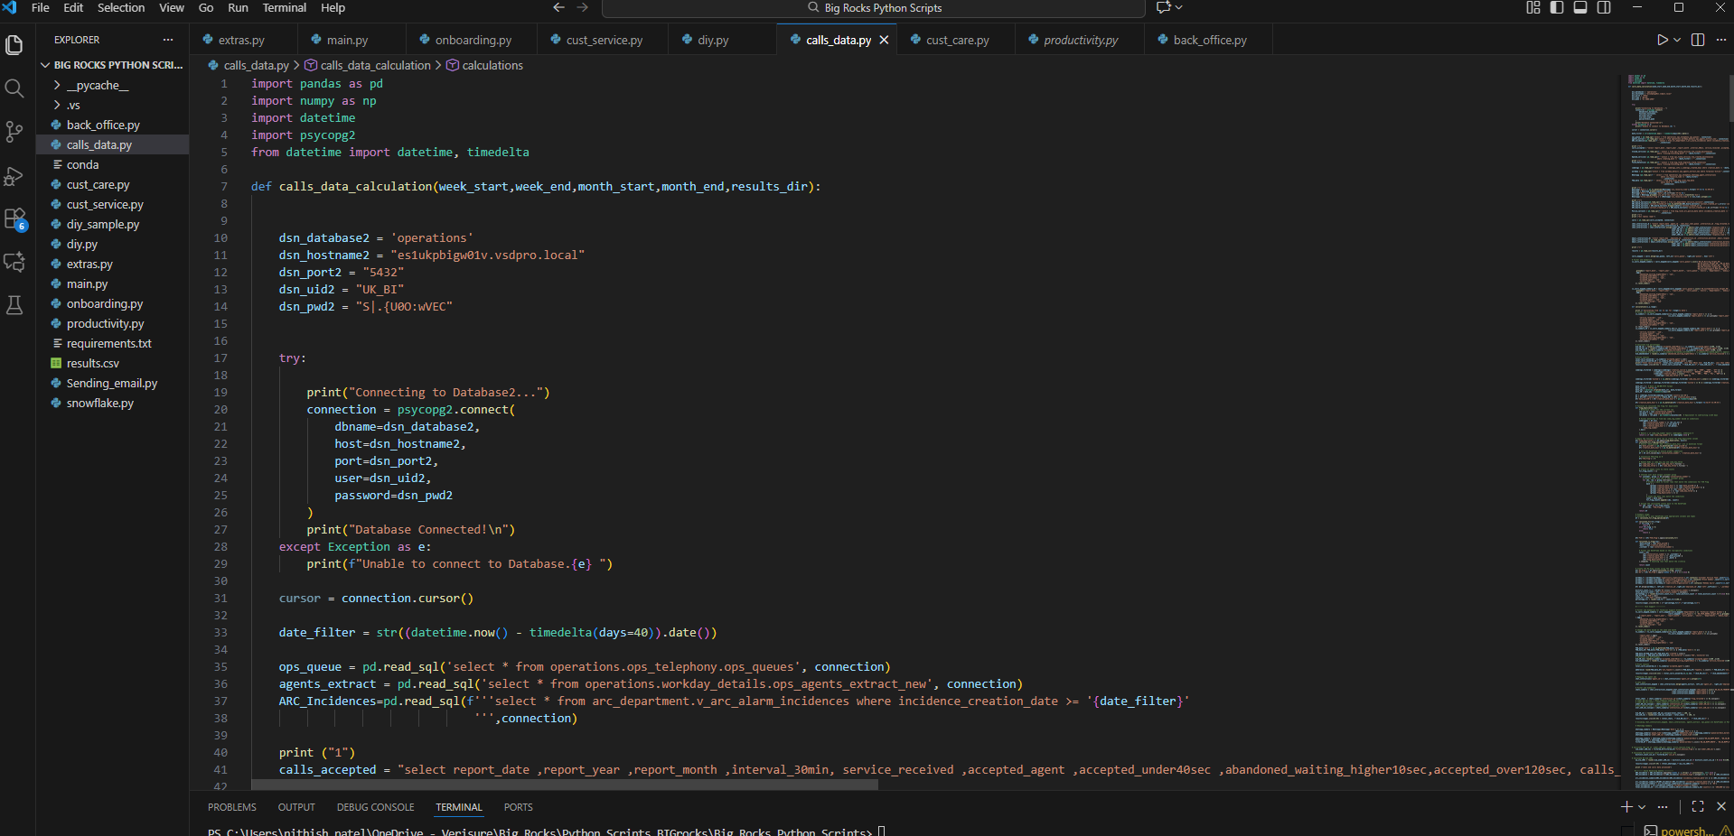
Python modules and KPI logic
Each Python module mirrors an operational area and encodes channel-specific business rules:
- Calls and SLA performance
  - Calculates SLA% for calls based on the proportion of calls answered within target thresholds.
  - Computes call response times, queue times and abandonment behaviour to show where customers wait too long or drop out.
- Customer Care and Customer Service
  - Measures First Contact Resolution (FCR%), tracking how many enquiries are resolved in the first interaction without follow-ups or transfers.
  - Tracks desk retention rates, showing how many cases stay within the originating desk versus being bounced between teams, a key indicator of process quality and ownership.
- Back Office and Maintenance
  - Calculates finalized maintenances, highlighting how many technical or billing maintenance cases are completed versus pending, and how long they stay open.
  - Monitors backlog and age of open tasks to support staffing and prioritisation decisions.
- Digital and asynchronous channels
  - Measures WhatsApp response times and service levels for digital messaging, aligning them with call-centre targets to provide a unified view of responsiveness.
  - Evaluates DIY/self-service journeys, showing how much volume is successfully deflected from assisted channels versus where customers still escalate.
- Security interventions
  - Tracks guard callouts and police callouts arising from alarms or incidents, giving leadership visibility of the most critical, safety-related interactions.
  - Links callouts back to call and maintenance data so leaders can understand patterns and potential process improvements.
main.py coordinates all modules, applies consistent reporting periods and parameters, then writes each KPI set into the right sheet and range of 15_09_2025_Big-Rocks.xlsx, preserving pre-built pivots and charts used in director-level meetings.
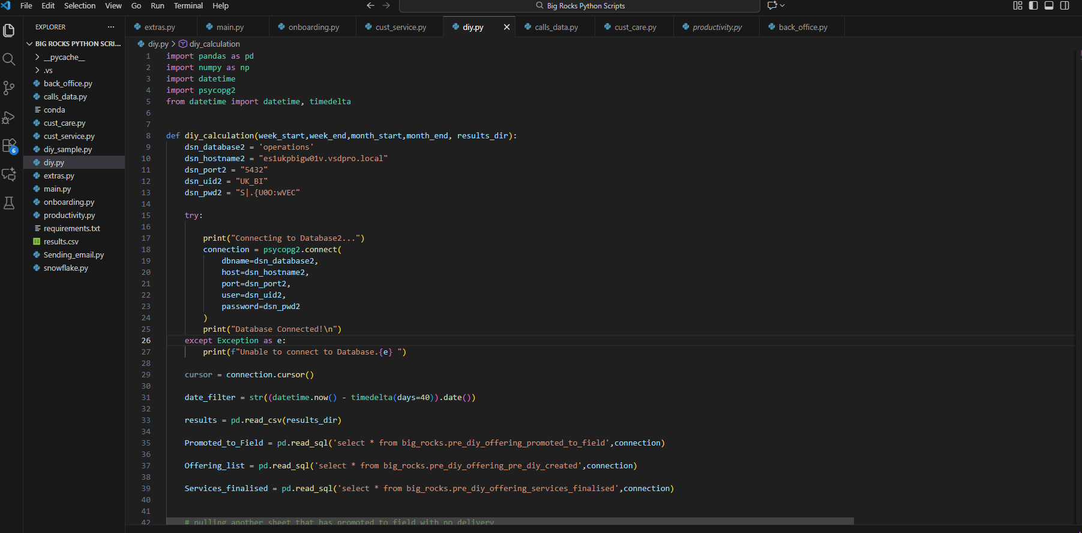

Report design and stakeholder experience
The resulting Excel file is structured around how leadership reviews performance: high-level Big Rocks summary sheets at the front, followed by detailed tabs for Calls/SLA, Customer Care, Customer Service, Back Office, DIY, Maintenance, and Callouts.
Directors open one file and immediately see headline metrics such as SLA%, FCR%, desk retention, finalized maintenances, average response times for calls and WhatsApp, and guard/police callouts, with the ability to drill into supporting tables if they need detail.
Engineering quality and impact
The project demonstrates:
- Robust data engineering: Airflow-scheduled refresh of multiple operational sources, followed by deterministic Python KPI calculation.
- Modular, testable Python design: clear separation by department, reusable helper functions and configuration-driven parameters.
- Rich domain expertise: KPIs are defined exactly as operations and security leaders use them—SLA%, FCR%, desk retention, maintenance completion, digital response times and physical callouts.
- Real business value: manual reporting effort is removed, and leadership can spend daily and weekly forums discussing actions instead of debating numbers.
This is positioned as the best project in the portfolio because it proves the ability to take complex, multi-channel operations data, encode nuanced business rules in Python, and deliver a reliable, executive-grade KPI engine that directly influences strategic and operational decisions.

